# Logging Into Wordpress

## Table of Contents

1. Getting to the login page
2. Logging In
3. After Logging In



Getting To The Login Page

Or just use this link here:<https://demo.mmtheatres.com/wp-admin>

Logging In

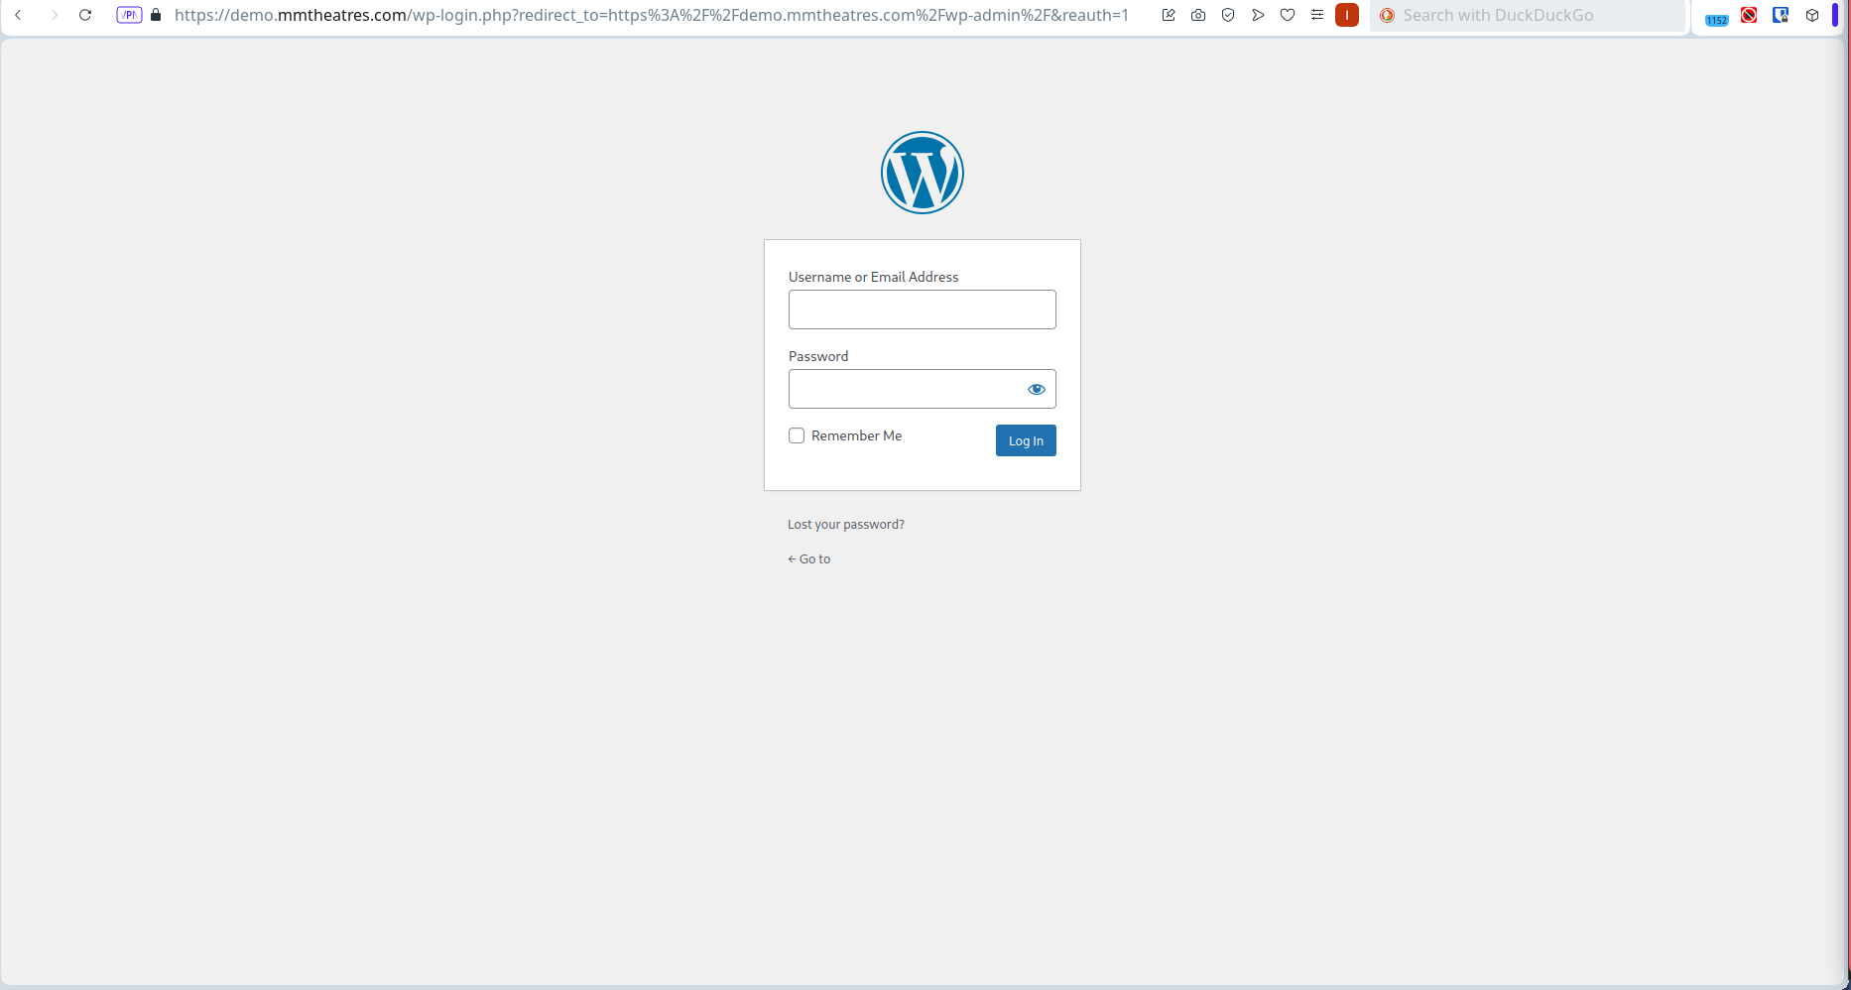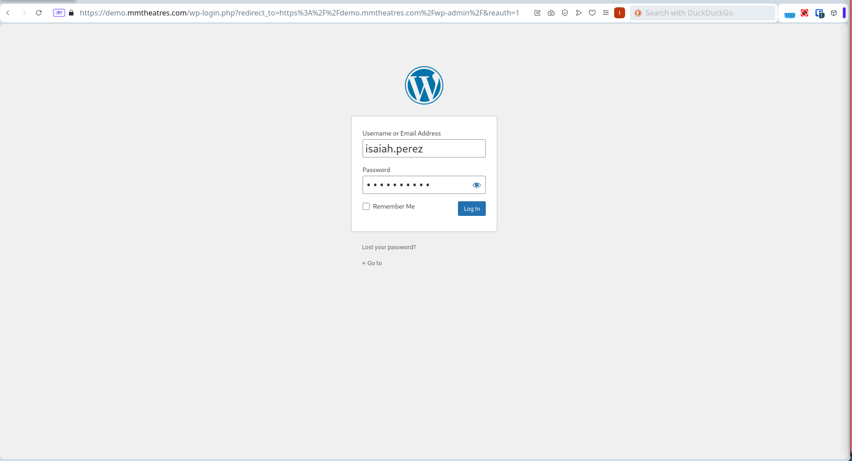

You should find yourself in a page like the one above, fill in your credentials you used for work computer or laptop. For example, if your name is John Doe then your username is john.doe and your password is the password you used to login your computer or laptop

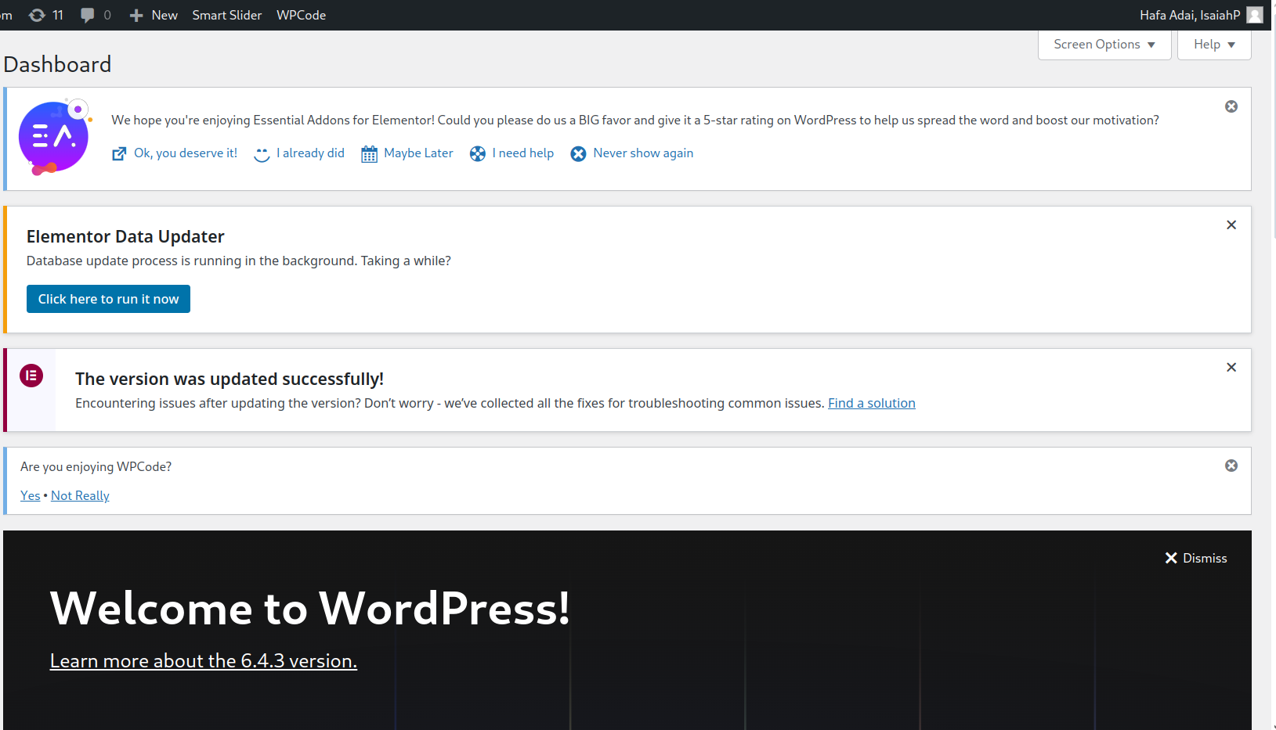

After Logging In

After logging in your credentials, you will be directed to the wordpress dashboard like the one above.